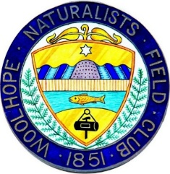
Herefordshire Parkland Conference 1-3 July 2026
BOOKING FORM AND INFORMATION

Part of the 175th Anniversary celebrations of the Woolhope Naturalists’ Field Club.

You can book for a single day, two days or all three. To book, please:

- Note your name and details below

Name:
Address:
Email: | Phone No:

- Complete this booking form below for each day on which you would like to attend, and email it to Professor Rachel Jenkins at rachel@olan.org

Please enter your name in the left hand column. If you would like to book and pay for others too, please add additional people. Please write YES in the appropriate box to indicate which parkland each person would prefer to visit in the afternoon, and please note any dietary requirements.

NAMES | Afternoon Site Visit Preference* |  | Dietary Needs
DAY ONE, 1 JULY 2026 | Brampton Bryan | Gatley Park
DAY TWO, 2 JULY 2026 | Eastnor / Bromsberrow | Moccas
DAY THREE, 3 JULY 2026 | Holme Lacy | Kentchurch
Please enter the total cost of your booking (at £40 per person per day) here: £

*Numbers are capped at 50 people per park per day. We will meet preferences wherever possible.

- To confirm your booking, please pay (£40 per person per day) by online banking to:
BANK: National Westminster Bank ACCOUNT NAME: Woolhope Naturalists Field Clb
SORT CODE: 53 50 41
ACCOUNT NUMBER: 05647843
Please write ‘PCON’ and your surname as the reference

By continuing, you agree that we confirm your booking and payment by email and use personal details you provide for conference administration. If you prefer to pay by credit card or cheque (or have any queries), please contact Prof. Rachel Jenkins by email at rachel@olan.org or by phone on 07921 251234.

Woolhope Naturalists’ Field Club February 2026

